Link: https://www.beamp.sg/apply-for-cycle6

Company Details

Name of Lead Applicant *
First Name
Last Name

Job Title of Lead Applicant*

Email*
example@example.com

Contact Number*

Country Code

Phone Number

Legal Name of Company *

Brand Name of Company

Company Website*

www.mycompany.com

Have you been incorporated in Singapore?*

Note: This is a mandatory requirement for funding for the programme

Country of HQ*

Select Country

No. of Year(s) of Incorporation *

e.g., 23

Latest FY Annual Revenue*

Please Select

Company Employment Size *
Please Select

How much funding have you raised? *
Please Select

Solution Details
Which track are you applying for? Select either one or both.*
- Accelerate Solution Development (ASD)
- Market Development (MD)

Note:
Accelerate Solution Development (ASD) - Your proposed solution still needs to be developed and refined before testing is done.
Market Development (MD) - Your proposed solution is ready to be tested in the market.

Which of the following challenge statements does your solution address?*
- CS1 – AI-Driven BIM Classification and [Team member] for SketchUp Components – M Moser Associates
- CS2 – Automated Compliance Checks for Multi-Agency Rules (Without IFC Conversion in BIM) – Forum Architects
- CS3 – Automated Compliance Validation for Submissions – SingHaiyi Group
- CS4 – Automated Design Compliance Checks for Internal Guidelines – CapitaLand Development
- CS5 – Automated Quality Inspection for Floor Tiling and [Team member] – Woh Hup
- CS6 – Automated System for Noise Barrier Installation on MRT Viaduct – Chuan Lim Construction Pte Ltd
- CS7 – Autonomous Cleaning Robot for Construction Site Maintenance – Penta-Ocean Construction Co., Ltd
- CS8 – Integrated Code Compliance During Design – WOHA Architects
- CS9 – Intelligent Verification System for Concrete Compliance and QA Risk Management – Expand Construction Pte Ltd
- CS10 – Modular and Composable AI Video Analytics for Construction Safety – Leighton Asia
- CS11 – Portable Drilling Device for High-Ceiling Installation Works Without Lifting Equipment – Dimeled Pte Ltd
- CS12 – Production Scheduling System for Prefabricated Units – Greyform Pte Ltd
- CS13 – Robotic Arm for Confined Space Construction Tasks – Obayashi Corporation
- CS14 – Robotic Manipulator for Precast Wall Panel Installation – JOE Green Marketing Pte Ltd
- CS15 – Robotic System for Vertical [Team member] – WOHA Architects and GWS Living Art
- CS16 – Sustainability Design Smart Advisor – Building System and Diagnostic (BSD)

How mature is your project?*
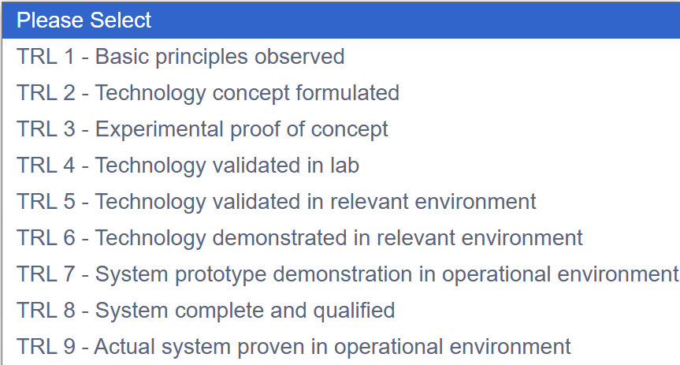

Please Select
This field is required.

Please select the relevant capabilities of your proposed solution

- Electronics
- Environment, Clean Air & Water, Waste
- Green Building
- Infocomm
- Logistics
- Manufacturing
- Materials
- Con-tech

Other capabilities not listed here.

Click HERE to download the Submission Guide to aid with crafting your proposal.

Please upload your proposal*
Upload your proposal. Drag and drop files here
Keep your total upload to less than 10MB

If available, please provide the link(s) to your solution demo or prototype demo

Please provide the relevant track record or CV of the participant and core development team (if any).
Upload relevant record(s). Drag and drop files here
Keep your total upload to less than 10MB

Please feel free to upload any additional materials that can help us in our evaluation
Upload supporting document(s). Drag and drop files here
Keep your total upload to less than 10MB

Others

What is/are your objective(s) for participating in the Built Environment Accelerate to Market Programme?*

How did you learn about BEAMP?*

